**AI vs ML vs DL vs DS — What You Need to Know**

What the terms ‘really’ mean, how they’re related, and how they’re applied

[[Anjolaoluwa Ajayi](https://medium.com/@dataprincess?source=post_page-----d401756b074c--------------------------------)](https://medium.com/@dataprincess?source=post_page-----d401756b074c--------------------------------)

[[GDSC Babcock Dataverse](https://medium.com/gdsc-babcock-dataverse?source=post_page-----d401756b074c--------------------------------)](https://medium.com/gdsc-babcock-dataverse?source=post_page-----d401756b074c--------------------------------)

[Anjolaoluwa Ajayi](https://medium.com/@dataprincess?source=post_page-----d401756b074c--------------------------------)

·

[Follow](https://medium.com/m/signin?actionUrl=https%3A%2F%2Fmedium.com%2F_%2Fsubscribe%2Fuser%2F191252a32a00&operation=register&redirect=https%3A%2F%2Fmedium.com%2Fgdsc-babcock-dataverse%2Fai-vs-ml-vs-dl-vs-ds-what-you-need-to-know-d401756b074c&user=Anjolaoluwa+Ajayi&userId=191252a32a00&source=post_page-191252a32a00----d401756b074c---------------------post_header-----------)

Published in

[GDSC Babcock Dataverse](https://medium.com/gdsc-babcock-dataverse?source=post_page-----d401756b074c--------------------------------)

·

5 min read

·

Sep 29, 2023

61

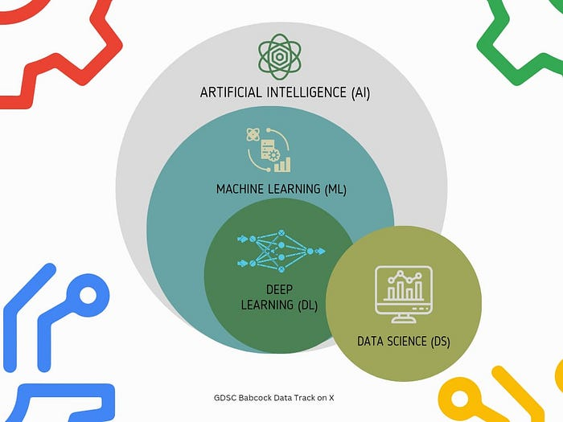

Visual representation of how AI, ML, DL, and DS are related

You’ve probably noticed the term AI popping up everywhere, from tech articles and social media to the apps you use daily.

Several apps that were once just regular tools now have new AI features and the apps that were AI-based all along now proclaim it more proudly.

It’s safe to say that Artificial Intelligence, or AI, is a term we’ve encountered more often than not as it’s constantly changing how we go about our daily lives.

So what exactly is AI, and how does it relate to its close relatives: Machine Learning (ML), Deep Learning (DL), and Data Science (DS)?

We’re going to find out in this blog post :)

**What is Artificial Intelligence (AI)?**

[Britannica](https://www.britannica.com/technology/artificial-intelligence) defined AI as the ability of a digital [computer](https://www.britannica.com/technology/computer) or computer-controlled [robot](https://www.britannica.com/technology/robot-technology) to perform tasks commonly associated with intelligent beings.

In more basic terms, AI is all about machines or software that can perform tasks that typically require human intelligence.

These tasks can include things like understanding natural language, recognizing patterns, making decisions, interacting with an environment, learning from experience, solving problems, and even exercising creativity.



Megatron Lazy Eyebrow GIF from Tenor

Now, you may have seen movies where AI-powered robots rise against humanity. It makes a good movie, but in real life, we’re a long way from robots dominating the world.

The more immediate concern with AI is not that they’ll become our overlords, but rather the potential risks that come from relying too much on AI systems.

For one, AI can make mistakes, especially if it’s trained on biased data. So, instead of fearing a robot uprising, we should focus on understanding the [limitations of AI](https://www.analyticsinsight.net/top-5-limitations-of-artificial-intelligence/) and adopting [responsible AI practices.](https://ai.google/responsibility/responsible-ai-practices/)

[**Types of AI**](https://builtin.com/artificial-intelligence/types-of-artificial-intelligence)

These are the seven types of AI to know, and what we can expect from the technology.

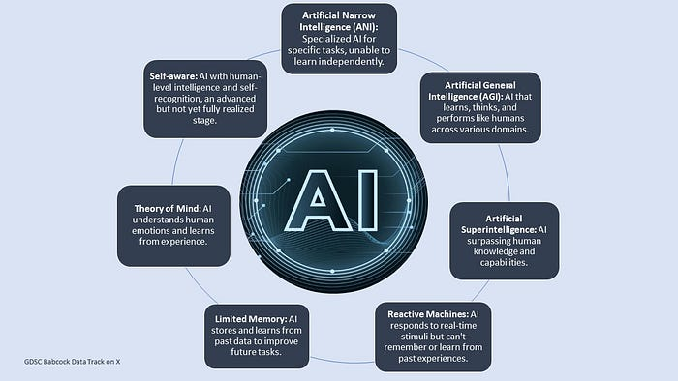

The 7 types of AI

AI is the big umbrella term that covers everything.

**What is Machine Learning?**

[IBM](https://www.ibm.com/topics/machine-learning) defined ML, or Machine Learning as a branch of [artificial intelligence (AI)](https://www.ibm.com/topics/artificial-intelligence) and computer science that focuses on the use of data and algorithms to imitate the way humans learn.

In simpler terms, ML is a subset of AI that focuses on creating algorithms and models that can learn from data. Instead of explicitly programming a machine to do something, you feed it data, and it learns how to do it on its own.

A few algorithms used in Machine Learning include Linear regression, decision trees, Naive Bayes, and K-means clustering. For more details on the most common ML algorithms, click [here](https://towardsdatascience.com/11-most-common-machine-learning-algorithms-explained-in-a-nutshell-cc6e98df93be).

**What is Deep Learning (DL)?**

Deep learning, according to [GeeksforGeeks](https://www.geeksforgeeks.org/introduction-deep-learning/), is a branch of machine learning that is based on artificial neural networks.

Essentially, deep learning is a subset of ML that involves the use of [neural networks](https://www.sciencedirect.com/topics/neuroscience/neural-network) to solve complex problems. And these neural networks are simply algorithms inspired by the human brain.

Deep learning models can recognize complex patterns in pictures, texts, sounds, and other data to produce accurate insights and predictions. You can use deep learning methods to automate tasks that typically require human intelligence, such as describing images or transcribing a sound file into text.

**What is Data Science?**

Data science combines math and statistics, specialized programming (Python, R, or SQL), advanced analytics, artificial intelligence (AI), and machine learning with specific subject matter expertise to uncover actionable insights hidden in an organization’s data. These insights can be used to guide decision-making and strategic planning. [Source: [IBM](https://www.ibm.com/topics/data-science)]

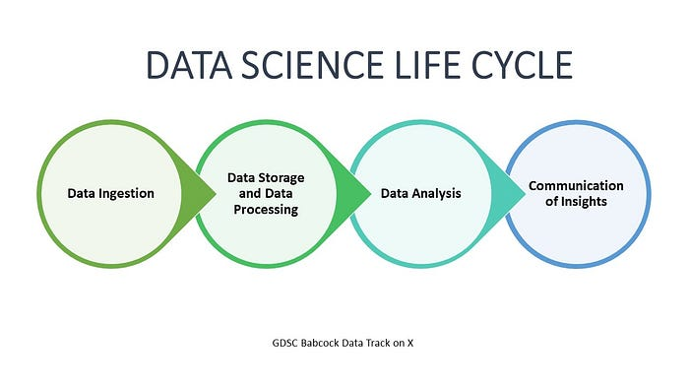

Data science life cycle [Source: [IBM](https://www.ibm.com/topics/data-science)]

**Popular Applications/ Use Cases of AI**

1. **Virtual Assistants:** AI-powered virtual assistants like Siri (Apple), Alexa (Amazon), and Google Assistant (Google)
2. **Recommendation Systems:** Companies like Netflix and Amazon use AI to recommend content and products to users based on their preferences and behavior.
3. **Autonomous Vehicles:** Tesla, Waymo (Alphabet), and Uber are developing self-driving cars using AI.
4. **Chatbots:** Many companies, including Facebook, use AI chatbots for customer support and engagement.

**Popular Applications/ Use Cases of Machine Learning**

1. **Fraud Detection:** PayPal and Square employ ML algorithms to detect fraudulent transactions and prevent financial losses.
2. **Natural Language Processing (NLP):** Google’s BERT and OpenAI’s GPT-3 are ML models powering various NLP applications, such as language translation and sentiment analysis.
3. **Image Recognition:**Companies like Facebook and Pinterest use ML for image recognition in photo tagging and content recommendations.
4. **E-commerce Forecasting:** Alibaba and Amazon use ML to predict customer demand, optimize inventory, and improve sales forecasting.

**Popular Applications/ Use Cases of Deep Learning**

1. **Computer Vision:** Tesla’s Autopilot system employs deep learning for advanced image recognition in autonomous driving.
2. **Speech Recognition:**Amazon’s Alexa, Apple’s Siri, and Google’s Assistant utilize deep learning for natural language understanding and voice commands.
3. **Image Generation:**NVIDIA’s GANs (Generative Adversarial Networks) create realistic images, while DeepDream creates psychedelic art.
4. **Language Translation:** Google Translate uses deep learning models like Transformer to provide accurate translations across languages.

**Popular Applications/ Use Cases of Data Science**

1. **Business Intelligence:**Tableau and Qlik provide data visualization and analytics tools for businesses to make data-driven decisions.
2. **Finance:**Companies like Goldman Sachs and JPMorgan Chase use data science for risk assessment, algorithmic trading, and fraud detection.
3. **E-commerce Analytics:** Amazon and Walmart use data science for pricing optimization, inventory management, and customer behavior analysis.
4. **Marketing Analytics:**Adobe Analytics and HubSpot use data science to analyze marketing campaigns, customer segmentation, and conversion rates.

**Common Data Career Paths**

*SOURCE: LinkedIn Jobs*

1. Data Scientist
2. Data Engineer
3. Machine Learning Engineer
4. Business Intelligence Analyst
5. ML Product Manager
6. Computer Vision Engineer
7. NLP Engineer
8. Reinforcement Learning Engineer
9. AI Research Scientist
10. AI Product Manager
11. AI Consultant
12. AI Developer
13. Deep Learning Research Scientist
14. Computer Vision Specialist
15. Natural Language Processing Specialist

**Call-To-Action**

If you liked this article, don’t forget to leave as many claps as you can so more people see it and share it with other data enthusiasts you know.

For more data-related articles, follow [GDSC Babcock Dataverse](https://medium.com/gdsc-babcock-dataverse).